**“Signals and Systems”**

**Project Report**

**DTMF pitch based number recognition**

**Group 2**

**U1810152 Khondamir Anvarov**

**U1810271 Georgiy Tsoy**

**U1810261 Shin Tatyana**

**U1810164 Trokoz Konstantin**

**The desired number**

**Our recording’s (name of the file “Project1_v2.wav”) dialed number was:**

**7 5 6 5 9 7 8 1 0**

**Also, we are successfully implemented automatic number recognition in our MATLAB script software, you can easily get needed combination of numbers out of your audio file.**

1. **In processing the signal, the reading of it was a first step**
2. **1Dimensional 10th order Median filtering to make signal smoother**
3. **Bandpass filter with band pass region 695-1480 Hz**
4. **imilate() function to get the indexes of loud regions(beginning and ending of regions are cut by 1000 values to make the regions solid and easier to work with)**
5. **fft() function to make Fast Fourier Transform at every loud segment**
6. **Some coding routine to correct the errors due to noise**
7. **Some coding routine to make everything work**

**The RAR file includes recording for our team, the “FFT.m” MATLAB code file and user manual**

**Original not filtered noisy signal**

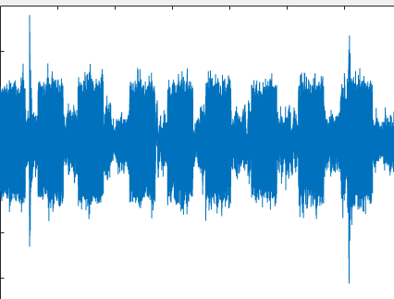

**Filtered and smoothed signal**

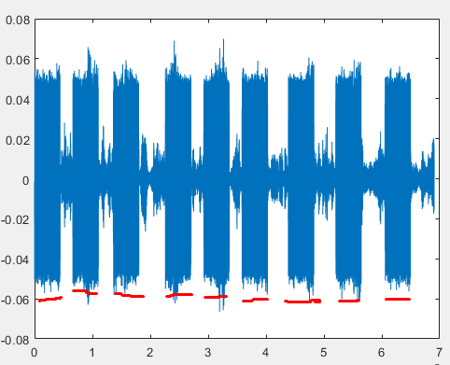

**Red indicates the loud regions where DTMF number has been detected:**

**7 5 6 5 9 7 8 1 0**